

**PANDIT DEENDAYAL ENERGY UNIVERSITY**

**Blog Web Application**

**Submitted By:**

Rajan Gautam (19BCP101)

Prakhar Jajoo (19BCP094)

Table of Contents

**Introduction 2**

**Features 2**

**Tech Stack / Services Used 2**

**Repository Links 3**

**Web App Links: 3**

**Client-Side Application: 3**

**Server API: 3**

**Web App Screenshots: 3**

**Home Page: 3**

**Posts Page: 5**

**Blog Category View: 6**

**Post Detail View: 7**

**Create Blog View: 8**

**Update Blog View: 9**

**Delete Blog: 9**

# Introduction

A blog web app where one can view blogs from various bloggers from PDEU. One needs to sign up or login with their PDEU’s Gmail account only in order to write their own blogs. This blog app is personalized just for staff and students of PDEU.

# Features

* **Google Authentication:** One can only use their PDEU Gmail accounts to write content on the web app which makes sure outsiders do not enter and spam the app.
* **Dark/Light Theme:** Our application supports Dark and Light themes which allows the user to select a theme comfortable to their eyes.
* **Basic Blog Operation:** Blogs can be edited, updated and deleted only by the author of the blog after they are posted.
* **Rich Text Editor:** Writing the blogs is very simple as user is provided with formatting options that makes a blog look organized and attractive. There is no limitation in the length of blog content.
* **Blog Category:** Each blog can be assigned to any pre-defined category which can be used to filter blogs based on their category.

# Tech Stack / Services Used

1. React: Frontend JavaScript Library
2. Node: Open-Source Server Environment
3. Express: Library for creating scalable backend APIs
4. MongoDB: NoSQL Database
5. Redux: Easier way to manage data in browser
6. Chakra.UI: UI library for creating beautiful designs
7. Cloudinary: For storing blog images
8. Heroku / Netlify / DevOps / GitHub / Azure

# Repository Links

1. **GitHub**: <https://github.com/rgautam320/MERN-Blog-Website>
2. **Azure DevOps**: <https://dev.azure.com/rgautam0320/AWT%20Lab/_git/Blog%20Website>

# Web App Links:

## Client-Side Application:

1. **Netlify** - <https://awt-lab-blog-website.netlify.app>
2. **Azure** - <https://awt-lab-blog-website.azurewebsites.net>

## Server API:

1. **Heroku**: <https://awt-lab-blog-website-api.herokuapp.com/>
2. **Azure**: <https://awt-lab-blog-website.azurewebsites.net/>

# Web App Screenshots:

## Home Page:

Both Dark Mode and Light Mode are available in our app. If you are authenticated, you will see option to post new blog and logout.

If you’re not authenticated, you will see an option to login with Google.

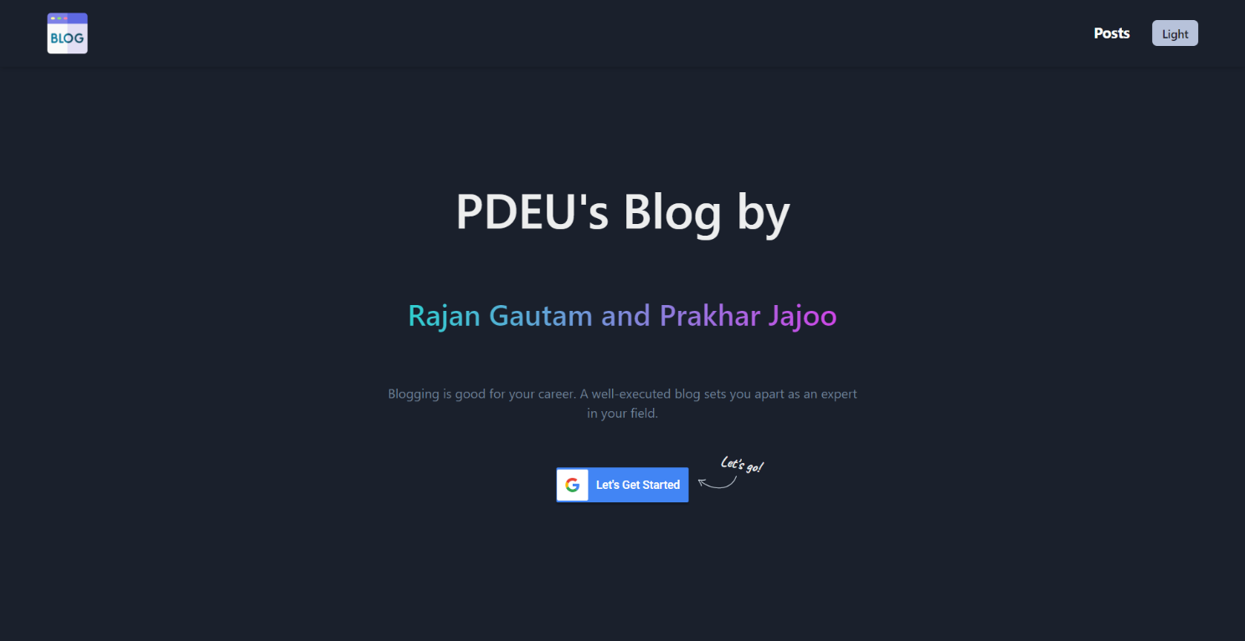

After Login:

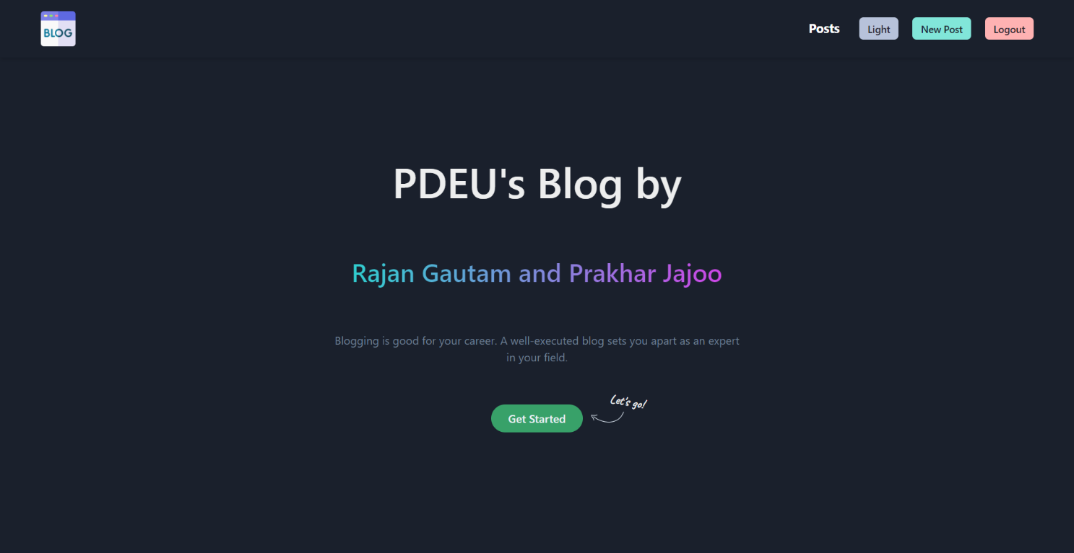

Light Mode:

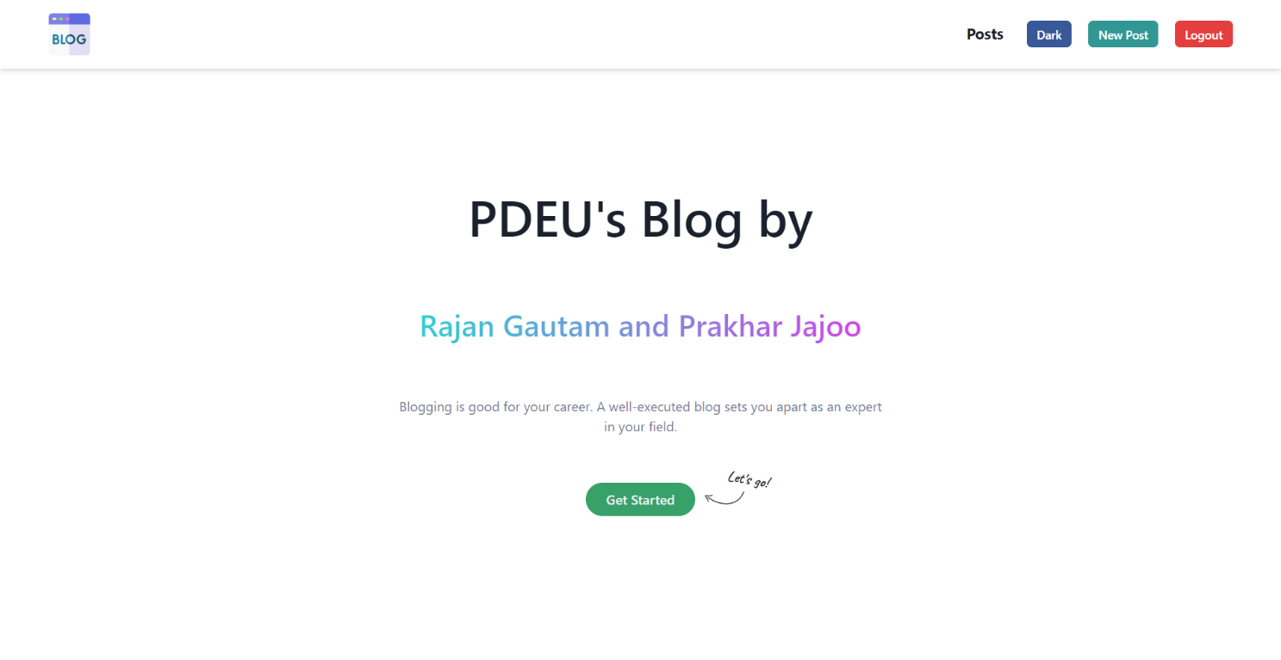

## Posts Page:

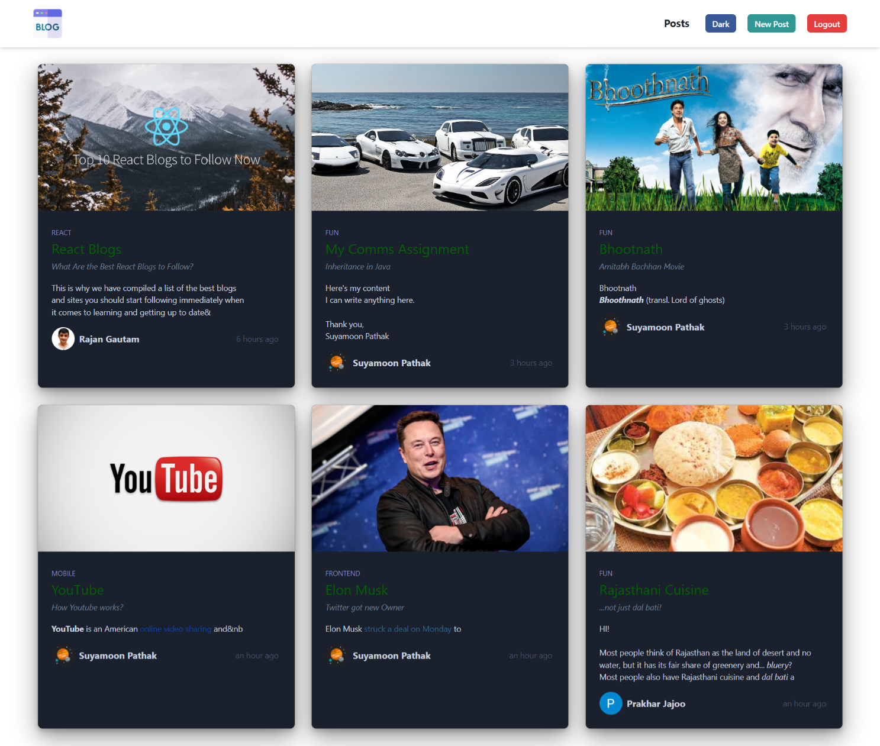

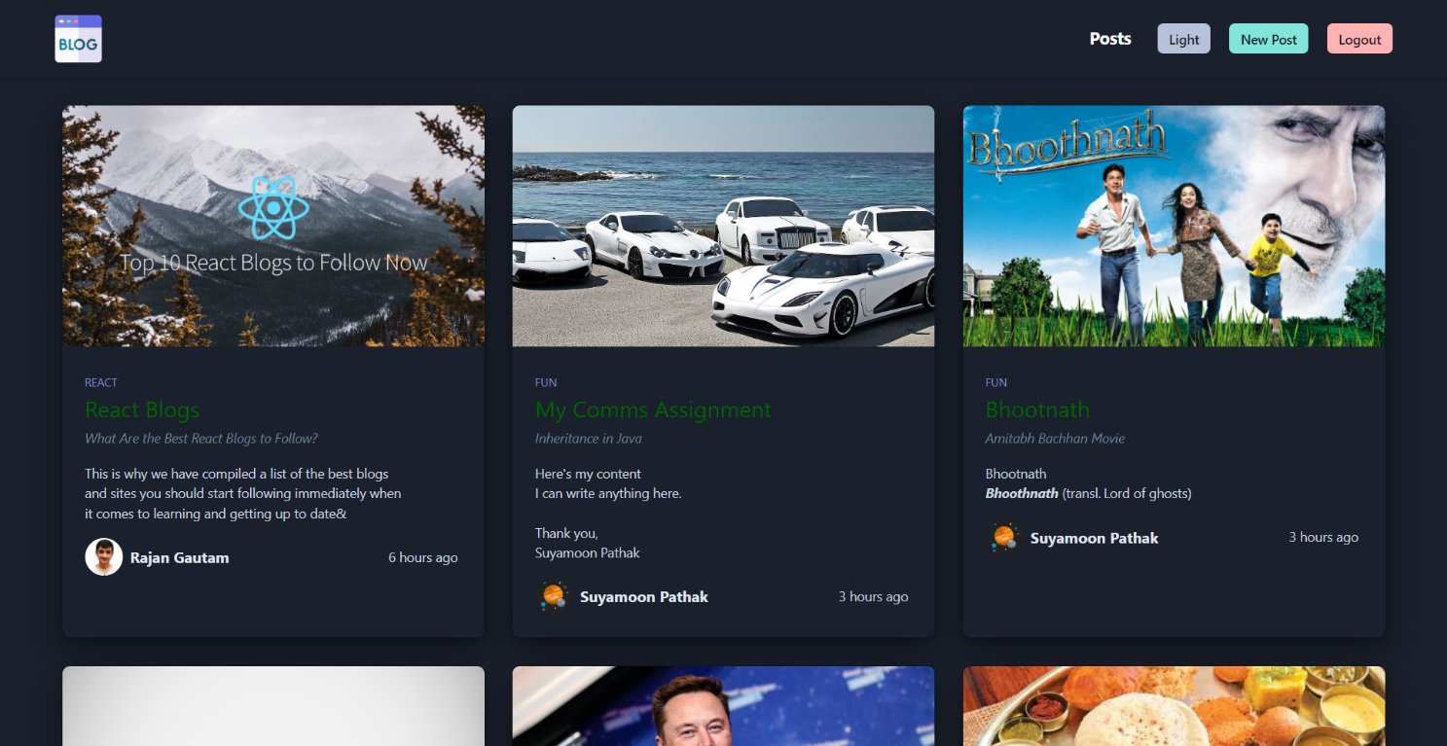Dark Mode:

## Blog Category View:

You can view the blogs based on the category of your choice.

Light Mode:

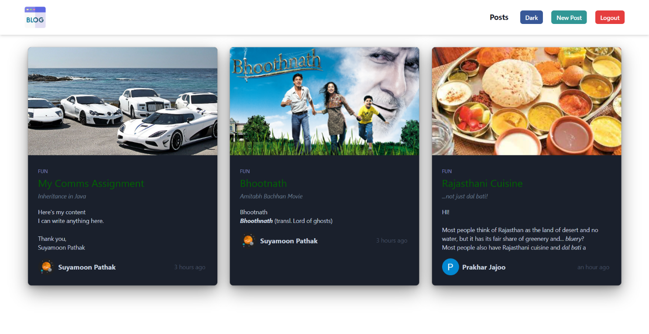

Dark Mode:

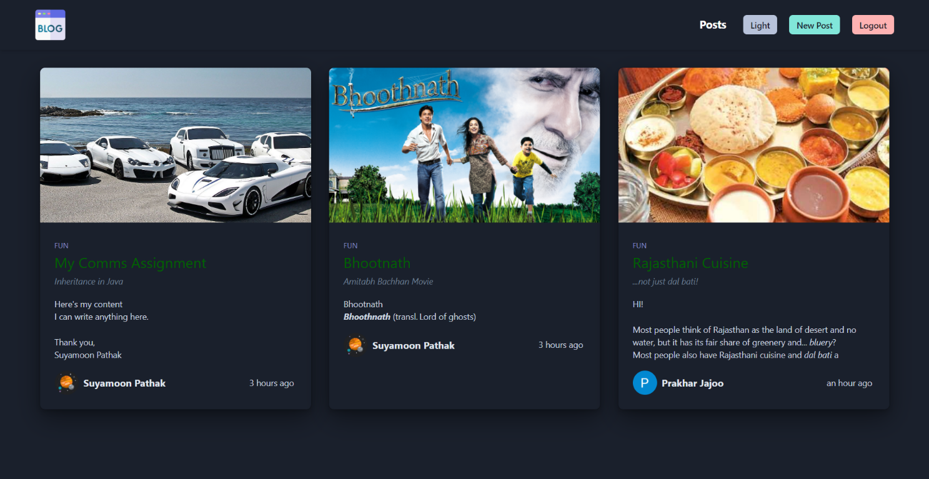

## Post Detail View:

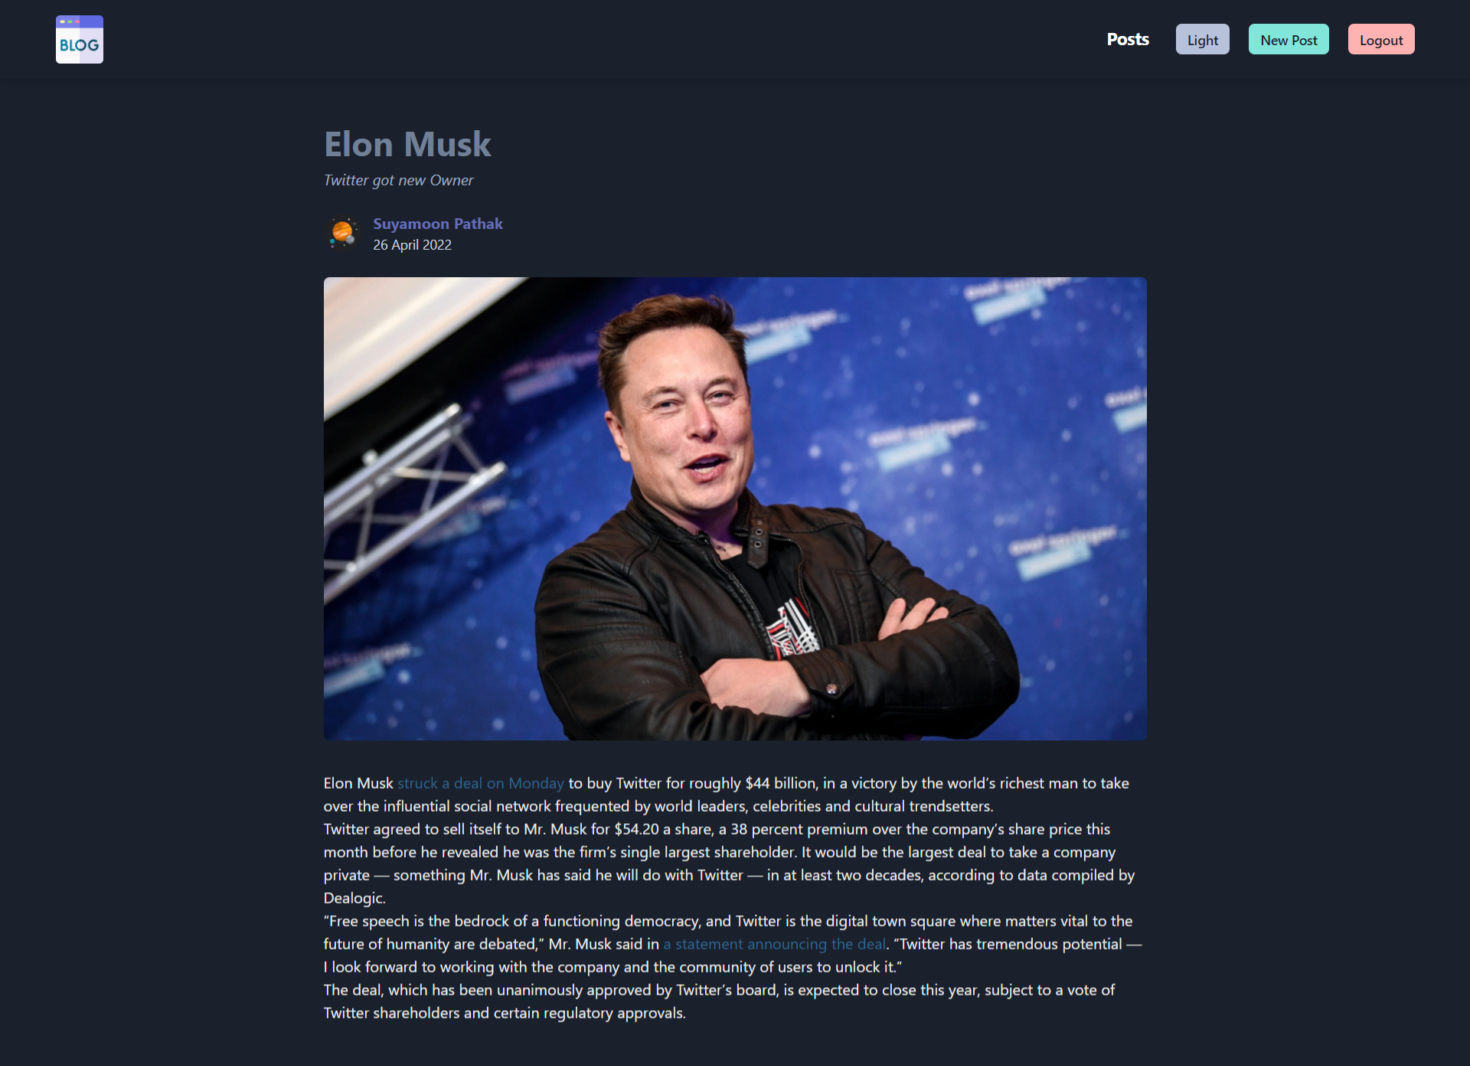

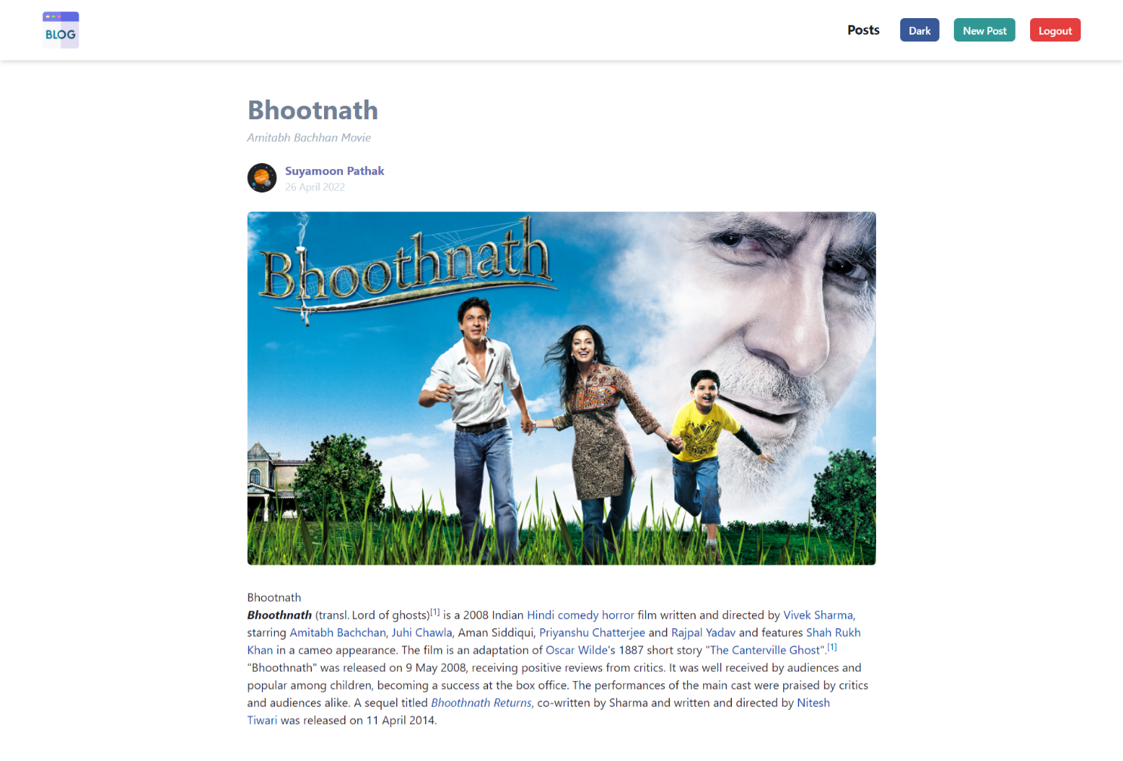

If you’re the author, you’ll see options to Edit or Delete your blog.

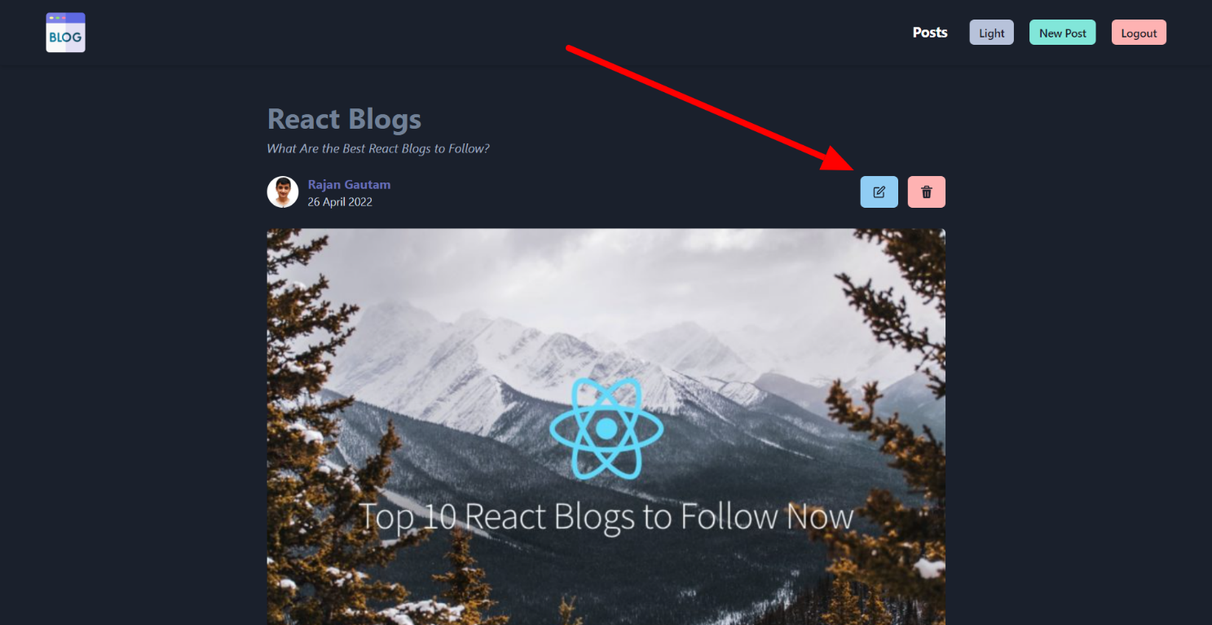

## Create Blog View:

If you’re logged in, you can create your own blog. We are providing, rich text editor to format your blog as you want.

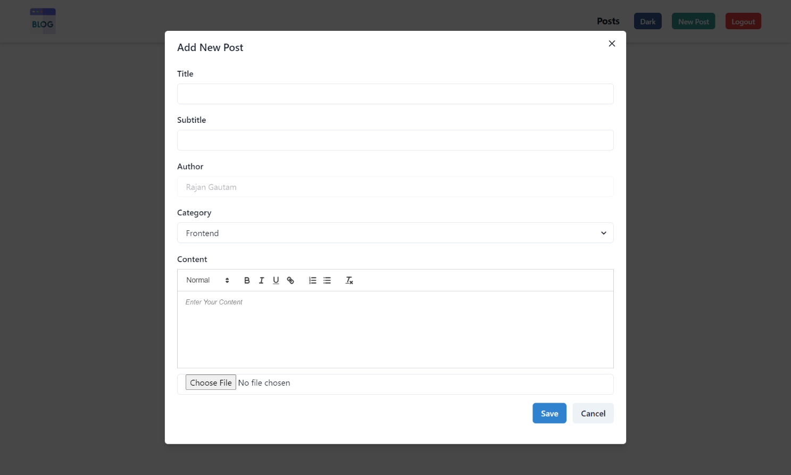

## Update Blog View:

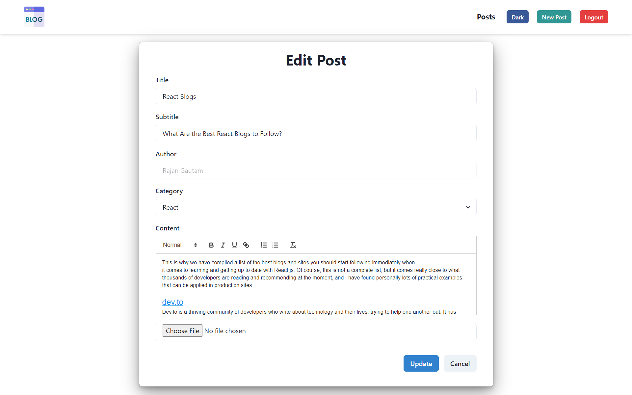

## Delete Blog:

If you’re the author, then you can delete your blog. A popup will come to confirm the delete action.

